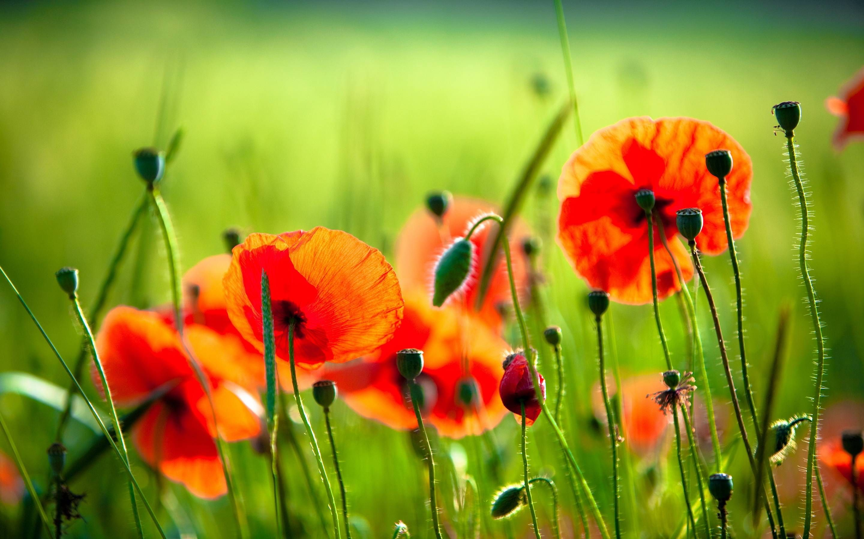
Hill Croome Parish
Act of Remembrance

Reading of the Names

‘They shall grow not old, as we that are left grow old.
Age shall not weary them, nor the years condemn.
At the going down of the sun and in the morning
We will remember them.’

Last post.

Two minutes silence.

Reveille.

Wreath laying.

‘When you go home, tell them of us and say,
For your tomorrow, we gave our today.’

Sunday 9th November 2025

HILL CROOME MEMORIAL

Gather at 10.50am

There is a Service held at Earl’s Croome Parish Church at 10.00am

